P 6 Configuring OSPF for IPv6
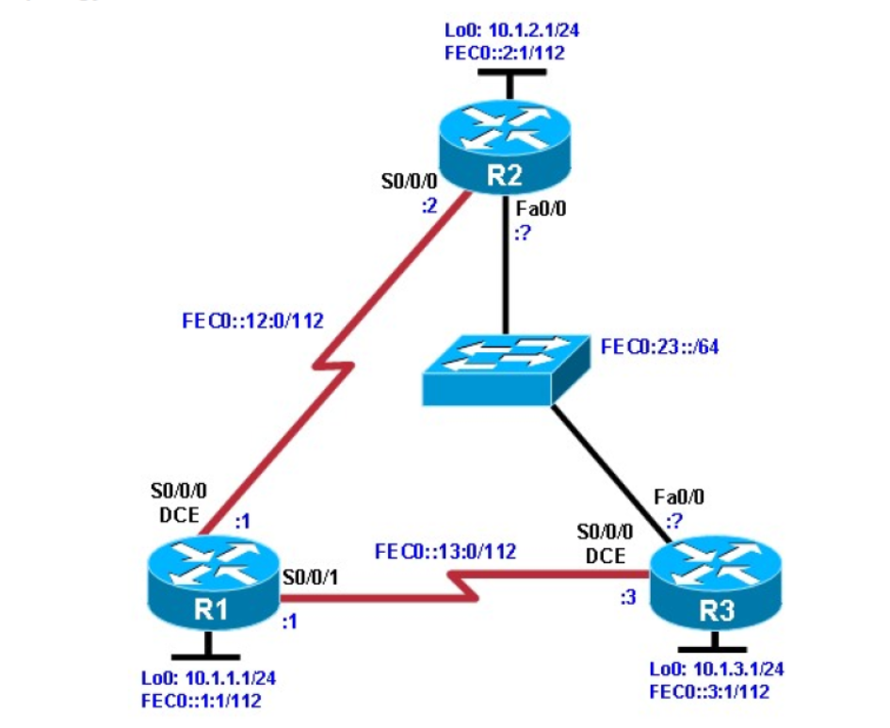

Background
In this lab, you configure static IPv6 addresses and EUI-64 IPv6 addresses on interfaces. You then configure
OSPFv3 to route between the IPv6 networks.

Objectives
• Configure a static IPv6 address on an interface.
• Change the default link-local address on an interface.
• Configure an EUI-64 IPv6 address on an interface.
• Enable IPv6 routing and CEF.
• Configure and verify single-area OSPFv3 operation

Step 2: Configuring the hostname and loopback interfaces.

Router(config)# hostname R1
R1(config)# interface loopback0
R1(config-if)# ip address 10.1.1.1 255.255.255.0 \
R1(config-if)# ipv6 address FEC0::1:1/112

Router(config)# hostname R2
R2(config)# interface loopback0
R2(config-if)# ip address 10.1.2.1 255.255.255.0
R2(config-if)# ipv6 address FEC0::2:1/112

Router(config)# hostname R3
R3(config)# interface loopback0
R3(config-if)# ip address 10.1.3.1 255.255.255.0
R3(config-if)# ipv6 address FEC0::3:1/112

Step 3: Configure static IPv6 addresses.

R1(config)# interface serial0/0/0
R1(config-if)# ipv6 address FEC0::12:1/112
R1(config-if)# clockrate 64000
R1(config-if)# bandwidth 64
R1(config-if)# no shutdown
R1(config-if)# interface serial0/0/1
R1(config-if)# ipv6 address FEC0::13:1/112
R1(config-if)# bandwidth 64
R1(config-if)# no shutdown

R2(config)# interface serial0/0/0
R2(config-if)# ipv6 address FEC0::12:2/112
R2(config-if)# bandwidth 64
R2(config-if)# no shutdown

R3(config)# interface serial0/0/0
R3(config-if)# ipv6 address FEC0::13:3/112
R3(config-if)# clockrate 64000
R3(config-if)# bandwidth 64
R3(config-if)# no shutdown

R1# ping FEC0::12:2
R1# ping FEC0::13:3

R2# ping FEC0::12:1

R3# ping FEC0::13:1

Step 4: Change the link-local address on an interface.

R1# show ipv6 interface serial 0/0/0

R2# show ipv6 interface serial 0/0/0

R1(config)# interface serial0/0/0
R1(config-if)# ipv6 address FE80::1 link-local

R2(config)# interface serial0/0/0
R2(config-if)# ipv6 address FE80::2 link-local

R1# ping FE80::2
R2# ping FE80::1

R1# show ipv6 interface serial 0/0/0

R2# show ipv6 interface serial 0/0/0

Step 5: Configure EUI-64 addresses.

R2(config)# interface fastEthernet 0/0
R2(config-if)# ipv6 address FEC0:23::/64 eui-64
R2(config-if)# no shutdown

R3(config)# interface fastEthernet 0/0
R3(config-if)# ipv6 address FEC0:23::/64 eui-64
R3(config-if)# no shutdown

R2# show ipv6 interface fastEthernet 0/0
R2# show ipv6 interface brief
R2# ping FEC0:23::218:B9FF:FECD:BEF0

R3# ping FEC0:23::218:B9FF:FE92:28D8

Step 6: Enable IPv6 routing and CEF.

R1(config)# ipv6 unicast-routing
R1(config)# ipv6 cef

R2(config)# ipv6 unicast-routing
R2(config)# ipv6 cef

R3(config)# ipv6 unicast-routing
R3(config)# ipv6 cef

7: Configure OSPFv3.

R1(config)# interface loopback0
R1(config-if)# ipv6 ospf 1 area 0
R1(config-if)# interface serial0/0/0
R1(config-if)# ipv6 ospf 1 area 0
R1(config-if)# interface serial0/0/1
R1(config-if)# ipv6 ospf 1 area 0

R2(config)# interface loopback0
R2(config-if)# ipv6 ospf 1 area 0
R2(config-if)# interface serial0/0/0
R2(config-if)# ipv6 ospf 1 area 0
R2(config-if)# interface fastEthernet 0/0
R2(config-if)# ipv6 ospf 1 area 0

R3(config)# interface loopback0
R3(config-if)# ipv6 ospf 1 area 0
R3(config-if)# interface serial0/0/0
R3(config-if)# ipv6 ospf 1 area 0
R3(config-if)# interface fastEthernet 0/0
R3(config-if)# ipv6 ospf 1 area 0

R1# show ipv6 ospf neighbor
R2# show ipv6 ospf neighbor
R3# show ipv6 ospf neighbor

R1# show ipv6 route
R2# show ipv6 route
R3# show ipv6 route

